SCHOOL OF COMPUTER SCIENCE & ENGINEERING

INTERNATIONAL UNIVERSITY, VNU-HCM

18th December 2021



**Course: Decision Support System lab**

**Lecturer: MSc. Nguyen Quang Phu**

**GROUP PROJECT REPORT**

**RESTAURANT RECOMMENDATION SYSTEM**

Students’ Name:

Nguyễn Thị Trường An – ITDSIU18002

Nguyễn Ngọc Khánh – ITDSIU18025

Lê Triệu Long – ITDSIU19044

***Table of Contents***

I. INTRODUCTION 1

1. Background 1

2. Motivations/Objectives 1

II. OVERVIEW 2

III. METHODOLOGY 3

1. Location based recommendation system 3

2. Content based recommendation system 4

3. Collaborative filtering recommendation system 5

IV. IMPLEMENTATION 6

1. Datasets 6

2. Front-end 7

3. Back-end 7

V. SUMMARY 10

1.Limitation 10

2.Future work 10

VI. TIMELINE 11

# INTRODUCTION

## Background

A Decision Support System (DSS) is an information system that allows data aggregation and data analysis through complex models to support unstructured or semi-structured decisions.This system has the function of providing information and assistance to managers throughout the process of formulating and approving management decisions. Managers can find the right data, select and use the appropriate models, and control the performance through professional means.

Users can utilize recommendation algorithms to find restaurants from a large number of options available on the web or through other electronic information sources. They show to the user a limited collection of products that are well matched to the description, given a wide set of objects and a description of the user's wants. Intelligent assistants for screening and choosing web sites, news stories, TV listings, and other information have recently been developed as part of recent work in recommendation systems.

## Motivations/Objectives

Having the desire not solely to fulfill the requirements for the Decision Support System course we take this semester, but to have a better understanding of the concepts in this state-of-the-art course, we decided to go and build a recommendation system.

We describe a personalized conversational recommendation system in this project that is designed to assist consumers in selecting a restaurant from a vast list of restaurants that are all of the same basic types. Our method is designed to assist users in finding a restaurant that suits their needs. It shows a decrease interact system-user interactions and the time it takes to discover a good restaurant.

We will then implement our recommendation system with the real world e-commerce datasets.

# OVERVIEW

Topic*: Restaurant Recommendation System*

Link of the e-commerce dataset: <https://www.kaggle.com/yelp-dataset/yelp-dataset>

For this project, we will be building 3 functions/ models to recommend restaurants based on Yelp Reviews in Portland:

* Location based recommendation system: we'll design a location-based recommendation system that takes into consideration a user's geographical position (longitude, latitude) when they use the app to recommend the top 10 local eateries based on proximity and total review scores.
* Content based recommendation system: After the user has started using our delivery app, we will create a collaborative-filtering and content-based recommendation system that takes into account the user's previous restaurant visits and recommends 10 restaurants based on those visits.
* Collaborative filtering recommendation system: The Collaborative Filtering system uses an item-item cosine similarity matrix to take into consideration a user's super score rating on eateries they've evaluated. To recommend similar restaurants, the Content Based approach considers keywords from a user's written review as well as restaurant categories.

# METHODOLOGY

## Location based recommendation system

Group Restaurants together based on geographical proximity using **K-Means Clustering**.

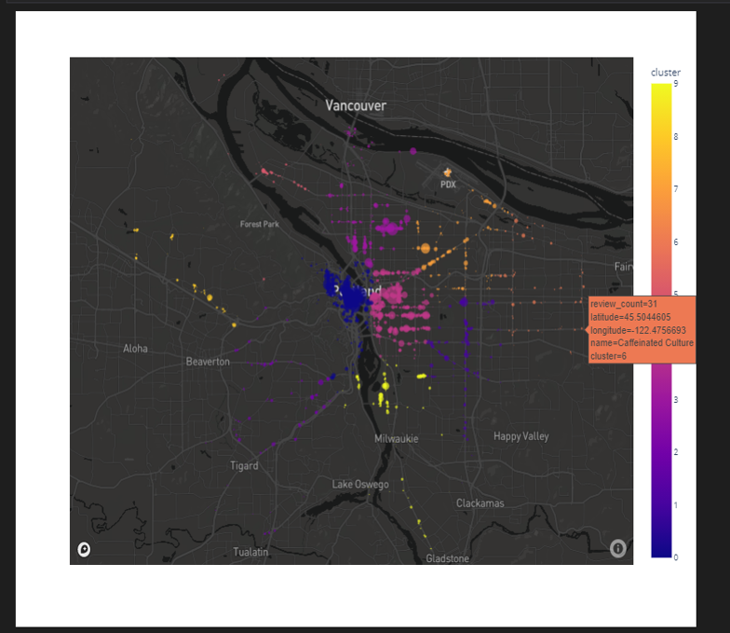

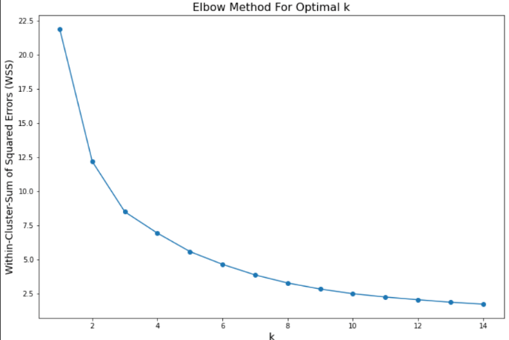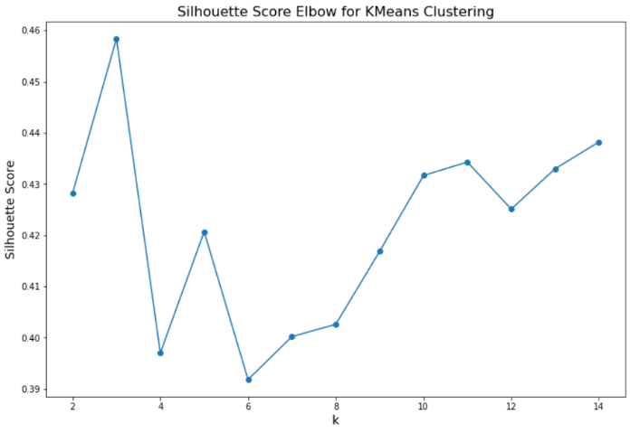

## Content based recommendation system

Collaborative Filtering finds a smaller set of users with tastes similar to a particular user.

It looks at the restaurants they like and combines them to create a ranked list of suggestions.

Steps:

1. Pivot Table on Super Score Ratings

2. Truncated Singular Value Decomposition

3. Item-Item Matrix based on Cosine Similarity

Algorithm used: **Cosine similarity**.

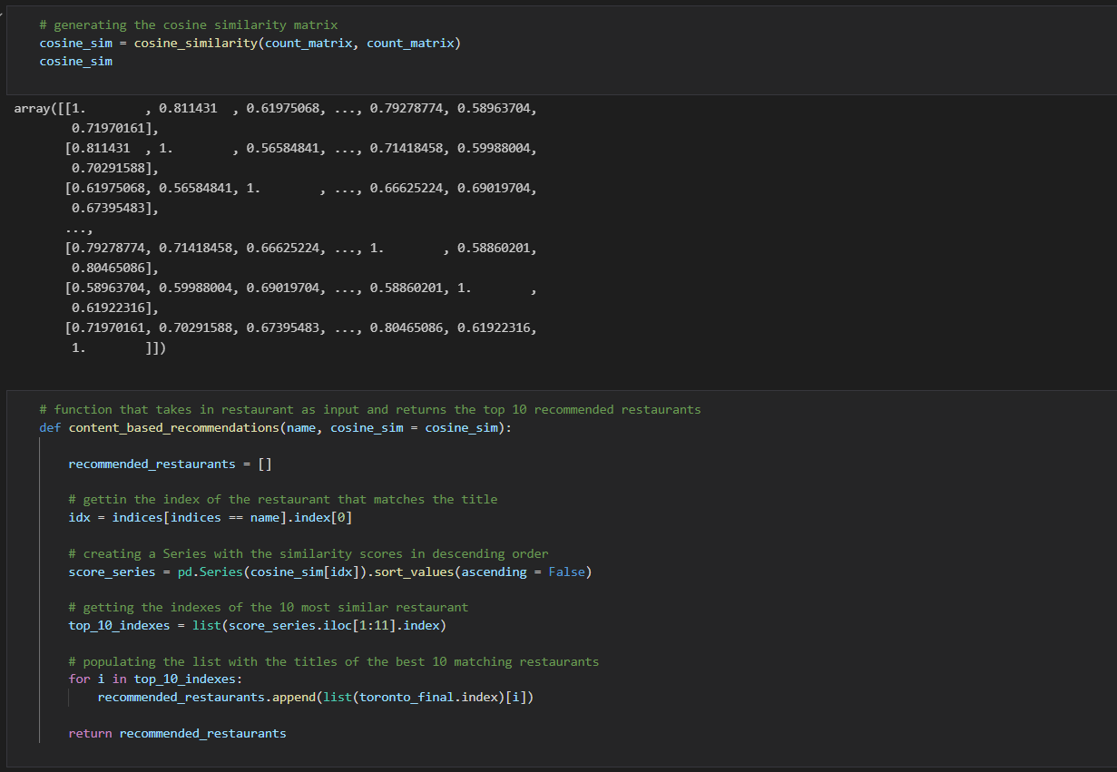

## Collaborative filtering recommendation system

Content-Based Recommendation recommends restaurants based on similar categories and keywords.

Steps:

1. Topic Modeling

2. CountVectorizer

3. Cosine Similarity

Algorithm used: **Cosine similarity.**

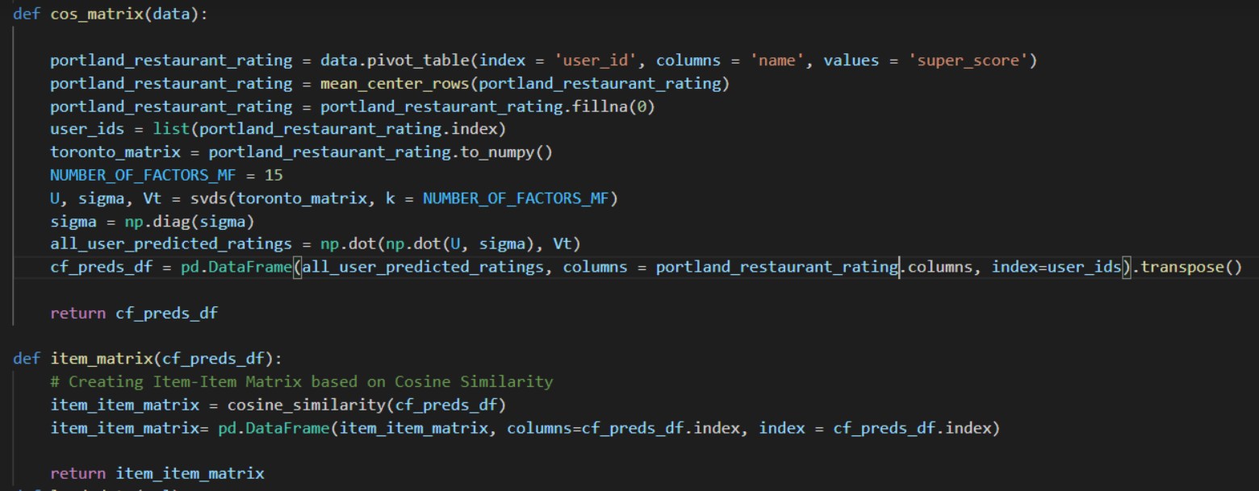

# IMPLEMENTATION

1. **Datasets**

We use three datasets:

* business_data.csv

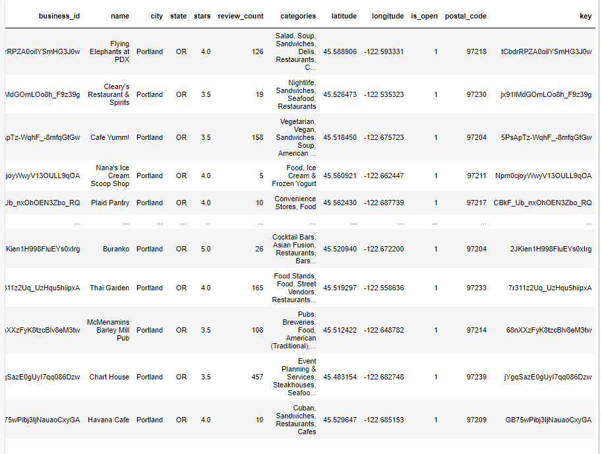

* bagOfWord.csv

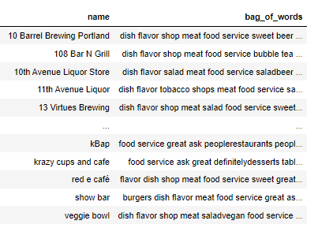

* portland_data2.csv

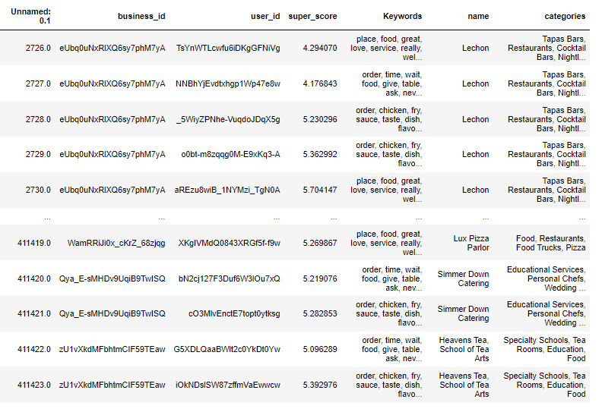

1. **Front-end**

Maps API: We used “plot.ly”

Template: We used “jinja2 of flask”

1. **Back-end**

Server: “Flask”

Function: We used pandas, numpy to read and process data.

* Function 1: We use the dataset “business_data.csv”

Input: longitude vs latitude



Output: sklearn.cluster.kmeans (data1[['longitude','latitude']])

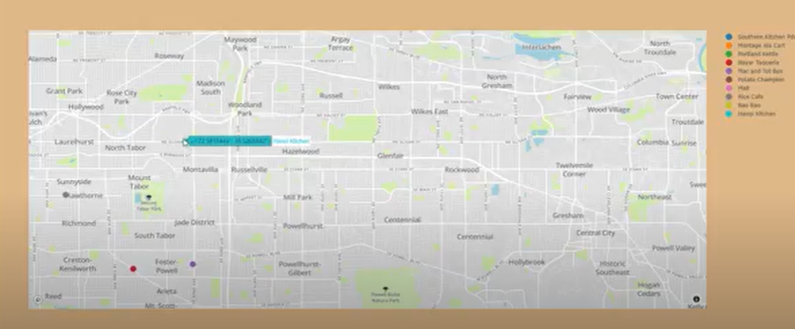

* Function 2: We use the dataset “bagOfWord.csv”

Input: User will choose 1 a restaurant of the output of function 1 and then click “Similar Restaurant”

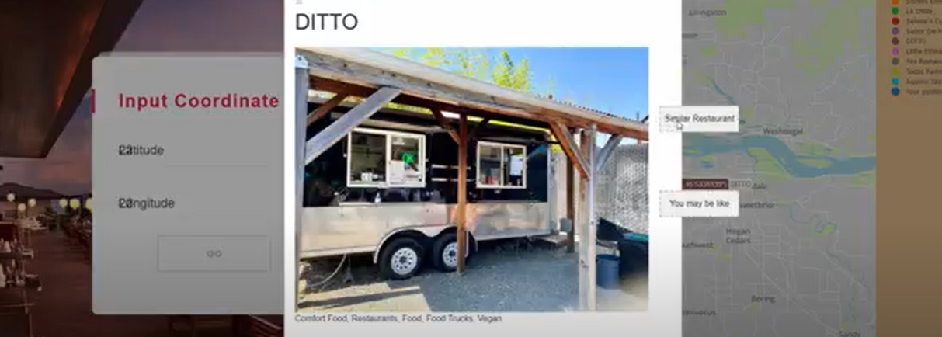

count_matrix= sklearn.CountVectorizer(data2 ['bag_of_words'] )

output=cosine_similarity(count_matrix,count_matrix)

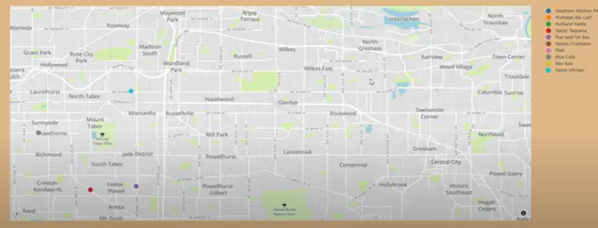

* Function 3: We use the dataset “portland_data2.csv”

input: User will choose 1 a restaurant of the output of function 1 and then click “You may be like”

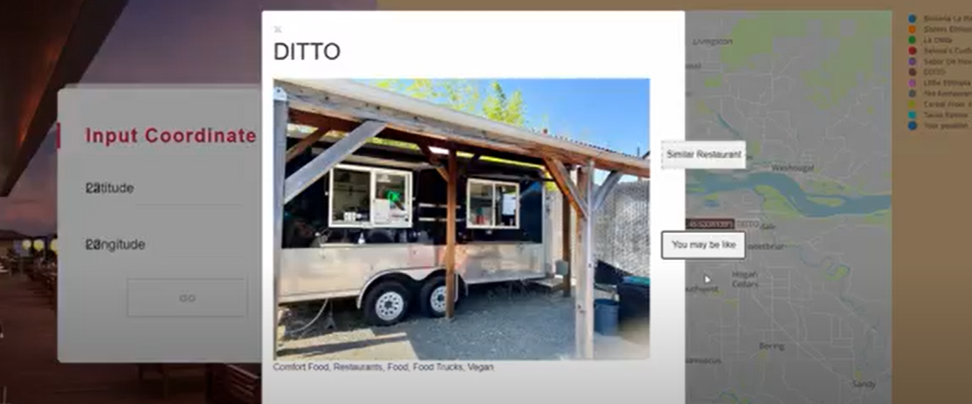

#Matrix factorization

cos_matrix=input.pivot_table(index = 'user_id', columns = 'name', values = 'super_score')

#Item Matrix

Item Matrix=cosine_similarity(cos_matrix)

#Recommend

Filtering for positively correlated restaurants

Output=Generate Top 10 Recommended Restaurants

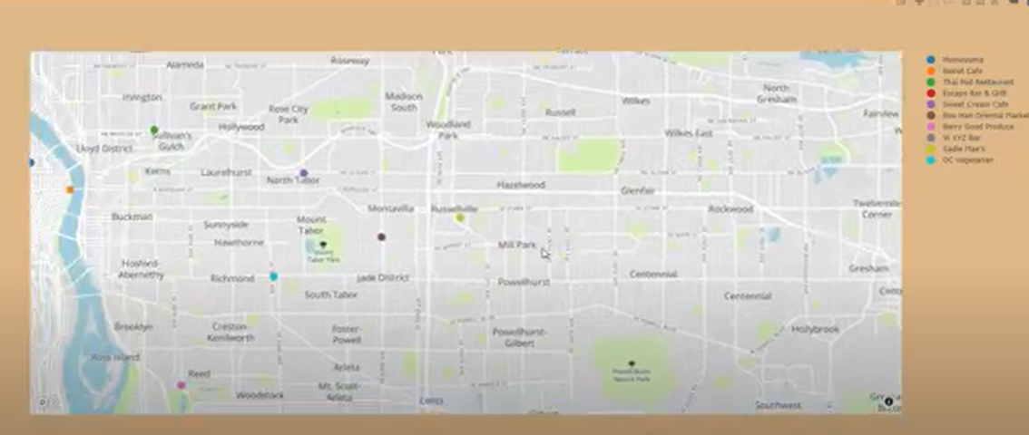

# SUMMARY

1. **Limitation**

Because of the Coronavirus, our group had difficulty communicating.

The data is large, so the program will take some time to run.

1. **Future work**

Detect user location.

Improve the program run better.

More restaurants will be updated, and the system will spread to many nations.

Allow users to comment and rate restaurant reviews then the restaurant's information is kept up to date.

A mobile platform can be used to implement the restaurant suggestion system.

# TIMELINE

| 30th October | 1st meeting for job assignment:   * An : find dataset, data cleaning and support Khánh to work with the function,write report, design the front-end. * Khánh : work with the function 1+2+3. * Long : work with the server, front-end. |
| --- | --- |
| 5th November | 2nd meeting for checking process:   * Finished function 1 (code) * Finished implementing server, routes,... |
| 15th November | 3rd meeting for checking process:   * Finished function 2 (code). * Finished implementing function 1 to server. |
| 25th November | 4th meeting for checking process:   * Finished function 3 ( code). * Finished implementing function 2 to serve. |
| 3rd December | 5th meeting for checking process:   * Finished implementing function 3 to server. * Record first demo. * Discuss for improvement. |
| 5th December | 6th meeting for checking process:   * Decorate the front-end. * Finished previous discussed ideas. * Discuss others based on the 2nd demo video. |
| 12th December | 7th meeting for writing report:   * An make prototype report, powerpoint * Discuss and finished report in day, training for presentation * Complete all the ideas * Finish the project |
| Contribution | Khánh: EDA and Sentimental Analysis, topic modeling and function 1+2+3 - 33.3%  An: data cleaning, write report, design the front-end, powerpoint - 33.3%  Long: create server, front-end and implement functions - 33.3% |